Title of report: Edge Detection
Prepared for: Mr. Umair
Prepared by: Mohsin Saeed
15-Jun-26

Contents
Image Detection Models 4
Step 4
Ramp 4
Roof 4
Image Intensity Function 4
First and Second Derivative 4
Techniques of Image Detection 4
Sobel Edge Detection: 4
Horizontal Kernel (𝐺𝑥): 5
Vertical Kernel (𝐺𝑦): 5
Implementation Steps 5
Canny Edge Detector 6
How it works: 6
1. Noise Reduction using Gaussian Blurring: 6
2. Gradient Calculation: 6
Strengths: 6
Weaknesses: 6
Prewitt Edge Detector 6
Steps: 7
Scharr Edge Detector 7
Laplacian Edge Detector 7
Sobel VS Prewitt VS Scharr 8
Challenges in Edge Detection 8
What is Non-Maximum Suppression (NMS)? 8
Here is the step-by-step: 8
1. Find the direction: 8
2. Look sideways: 8
3. Compare: 9
Suppress or Keep: 9
Color spaces 9
Common Color Spaces 9

Image Detection Models
The basic edge models are Step, Ramp and Roof.
Step: A step edge represents an abrupt (sudden and not expected) change in intensity
Ramp: A ramp edge describes a gradual transition in intensity over a certain distance
Roof: A roof edge represents a peak or ridge (a long)

Image Intensity Function
The image intensity function represents the brightness or intensity of each pixel in a grayscale image

First and Second Derivative
Derivative (rate of change of a function with respect to an independent variable)
- uses the first derivative (Sobel) to find the strength and direction of all edges.
- It then uses the second derivative concept to perform Non-Maximum Suppression—meaning, it checks along the edge direction and keeps only the pixels that are local maxima (peaks), and suppresses everything else. This thins the edge down to a single pixel width

Techniques of Image Detection
There are various types of edge detection techniques, which include the following:
- Sobel Edge Detection
- Canny Edge Detection
- Prewitt Edge Detection
- Scharr Edge Detection
- Laplacian Edge Detection
Sobel Edge Detection:
The Sobel operator uses two 3x3 convolution kernels (filters), one for detecting changes in the x-direction (horizontal edges) and one for detecting changes in the y-direction (vertical edges). These kernels are used to compute the gradient of the image intensity at each point, which helps in detecting the edges. Here are the Sobel kernels:
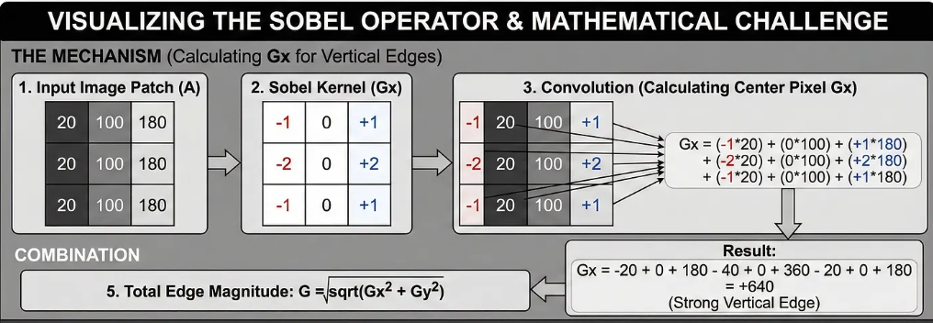

Horizontal Kernel (𝐺𝑥):
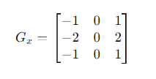

Vertical Kernel (𝐺𝑦):
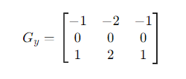
This kernel is used to detect edges by emphasizing the gradient in the x/y-direction.

Implementation Steps
Here’s the Step-by-Step Example:
- Load and Display the Image
- Convert to Grayscale
- Apply Gaussian Smoothing (Optional)
- Apply Sobel Operator (gradients in the x and y directions)
- Calculate Gradient Magnitude
- Normalization
- Display the Resulting Edge Image

Canny Edge Detector
The “Gold Standard” of edge detection. It is a multi-stage algorithm.

How it works:
- Noise Reduction using Gaussian Blurring: The first step in the Canny edge detection algorithm is to smooth the image using a Gaussian filter.
- Gradient Calculation: After noise reduction, the Sobel operator is used to calculate the gradient intensity and direction of the image
Strengths: Thin, clean edges and remove noise.
Weaknesses: Computationally more expensive requires parameter tuning (thresholds). 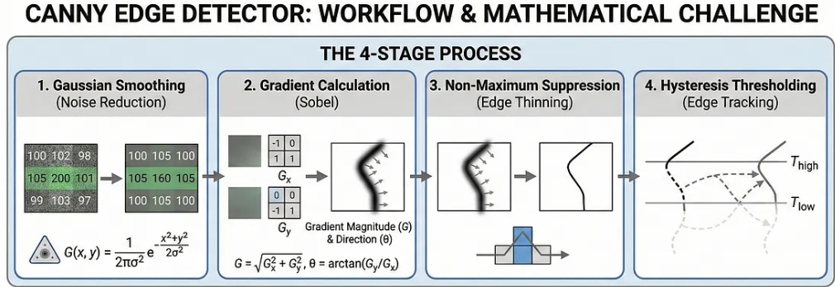

Prewitt Edge Detector
Prewitt operator is used for edge detection in images. It identifies both horizontal (x-axis) and vertical (y-axis) edges by detecting sudden changes in pixel intensities using a first-order derivative
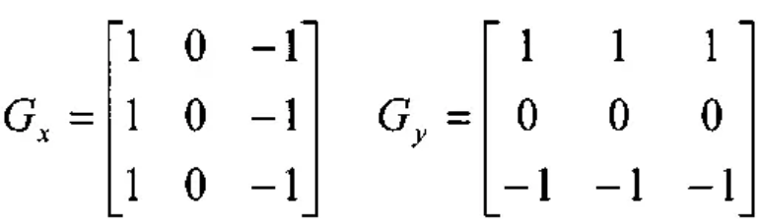

Steps:
- Read the image.
- Convert into grayscale if it is colored.
- Define the filter.
- Detect the edges along X-axis.
- Detect the edges along Y-axis.
- Combine the edges detected along the X and Y axes.
- Display all the images.

Scharr Edge Detector
The Scharr operator is a filtering method used to detect and highlight edges by computing image gradients using the first derivative. It is similar to the Sobel operator but provides better rotational symmetry and improved accuracy for edge detection.
- X-axis: [-3 0 3; -10 0 10; -3 0 3]
- Y-axis: [3 10 3; 0 0 0; -3 -10 -3]

Laplacian Edge Detector

Sobel VS Prewitt VS Scharr

Features | Prewitt | Sobel | Scharr
Objective | Simple edge detection with uniform gradient tracking | Balance edge with nose smoothing | Highly and precise edge detection
Uses | Fast processing on clean image | General Purpose | High precision CV, sub pixel edge detection
Noise | Poor | Good | Fair to good
Edge Detect | Low | Medium | Very good
Center weight | 1 (equal weight) | 2 (strong) | 10(very strong)

Challenges in Edge Detection
Edge detection can be challenging due to:
- Noise: High levels of noise can cause false edges.
- Texture: Complex textures can lead to missing edges.
- Illumination: Variations in lighting can affect edge detection accuracy.
- Scale: Objects of different scales may require different edge detection parameters.

What is Non-Maximum Suppression (NMS)?
NMS scans along the edge and asks, "Is this pixel the absolute tallest peak in its immediate neighborhood?" If the answer is yes, it keeps it. If the answer is no (meaning a neighbor has a higher gradient), it suppresses it (sets it to zero/black).

Here is the step-by-step:
- Find the direction: Remember that the first derivative (Sobel) gives you a direction (e.g., the edge is running north-to-south).
- Look sideways: NMS looks at the two neighboring pixels that are perpendicular to the edge direction. (If the edge runs North-South, you look at the East and West neighbors).
- Compare: It checks the gradient strength (the slope value) of the current pixel against those two neighbors.

Suppress or Keep:
  - If the current pixel has a higher gradient than both neighbors → It is the local maximum. Keep it (mark it white).
  - If either neighbor has a higher gradient → This pixel is on the "shoulder" of the slope. Suppress it (mark it black).

Color spaces
Color spaces are models used to represent and organize the color channels in an image.

Common Color Spaces
1. RGB (Red, Green, Blue)
2. BGR (Blue, Green, Red)
3. HSV (Hue, Saturation, Value)
4. CMYK (Cyan, Magenta, Yellow, Black)
5. Grayscale

